Please send entries / queries to: E-mail: tournaments@icu.ie
The 101st Irish Chess Championships 2022
Date: 2nd-10th July 20222
Venue: Talbot Hotel, Stillorgan
Guaranteed Prize Fund
Prize fund: €4,000
1st: €1,500

Time Control
105 minutes for the first 40 moves + 30 minutes for the rest of the game + 30 second increment from move 1.
Entry
GMs, IMs & FMs: Free
Rated over 2200: €50
Rated 2000-2200: €75
Rated below 2000: €100

Special: 25% off for Unwaged entrants. ICU ratings alone apply above.

Playing Schedule
Round 1: Saturday, July 2nd 3pm
Round 2: Sunday, July 3rd 3pm
Round 3: Monday, July 4th 3pm
Round 4: Tuesday, July 5th 3pm Round 5: Wednesday, July 6th 3pm Round 6: Thursday, July 7th 3pm Round 7: Friday, July 8th 3pm
Round 8: Saturday, July 9th 3pm Round 9: Sunday, July 10th 12.30pm

Current Top Seeds
FM Tarun Kanyamarala
IM Mark Quinn
FM Joe Ryan
FM Conor O’Donnell

Notes
- All players must be current members of the Irish Chess Union.
- Online entries will be taken on the ICU site - see here.
- At least 15 boards will be broadcast online.
- Entrants must be registered as IRL with FIDE. Event will be FIDE rated.
- For players rated over 1900 on the July 2018 ICU published rating list.
- The champion will be awarded a spot on the 2020 open Olympiad team.
- All sets and clocks will be provided.
- Further terms and conditions here.
The Irish Championships 2022: First weekender
Date: 1st-3rd July 2022
Venue: Talbot Hotel, Stillorgan
Guaranteed Prize Fund
€1,000
1st Prize: €500
2nd Prize: €250
3rd Prize: €100

Early Entry Fees
Standard: €35
Junior/OAP/Student: €30

Standard Entry Fees
Standard: €45
Junior/OAP/Student: €35

Late Entry Fees
Standard: €50
Junior/OAP/Student: €40

Time Control
90 minutes + 30 second increment
from move 1.

Round Times
Round 1 Friday, July 1st 7:00pm
Round 2 Saturday, July 2nd 11:00pm
Round 3 Saturday, July 2nd 4:00pm
Round 4 Sunday, July 3rd 10:00am
Round 5 Sunday, July 3rd 2:30pm
Prize-giving Sunday, July 3rd 6:45pm

Notes
- Two sections – Challengers (u1400) and Majors (1300-1900)
- All players must be current members of the Irish Chess Union.
- Online entries will be taken on the ICU site
- All sets and clocks will be provided.
- Further terms and conditions here.
- Event will be FIDE rated.

The Irish Championships 2022: Open Weekender
Date: 8th – 10th July 2022
Venue: Talbot Hotel, Stillorgan

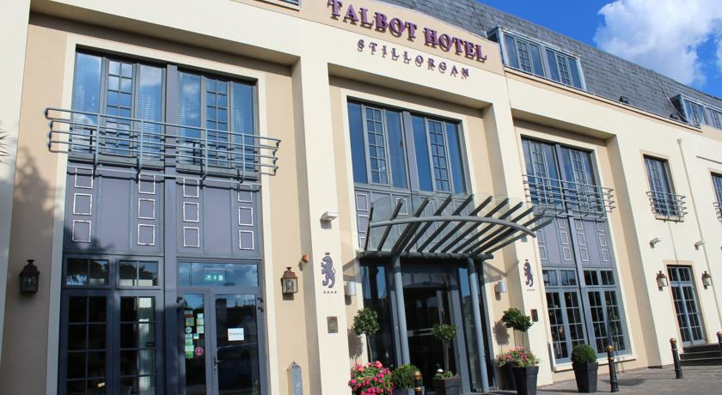
Grading Band
For players of any standard – there are no restrictions on rating, age or experience.
Guaranteed Prize Fund
€1500
1st Prize: €600
2nd Prize: €350
3rd Prize: €150

Early Entry Fees
Standard: €35
Junior/OAP/Student: €25

Standard Entry Fees
Standard: €45
Junior/OAP/Student: €35

Late Entry Fees
Standard: €50
Junior/OAP/Student: €40

Time Control
90 minutes + 30 second increment
from move 1.

Round Times
Round 1 Friday, July 8th 7:00pm
Round 2 Saturday, July 9th 11:00am
Round 3 Saturday, July 9th 4:00pm
Round 4 Sunday, July 10th 10:00am
Round 5 Sunday, July 10th 2:30pm
Prize-giving Sunday, July 10th 6:45pm

Notes
- All players must be current members of the Irish Chess Union.
- Online entries will be taken on the ICU site
- All sets and clocks will be provided.
- Further terms and conditions here.
- Event will be FIDE rated.
- Event is open to all federations.

The Irish Championships 2022: Weekday Open
Date: 4th – 8th July 2022
Venue: Talbot Hotel, Stillorgan

Grading Band
For players of any standard – there are no restrictions on rating, age or experience.
Guaranteed Prize Fund
€1500
1st Prize: €600
2nd Prize: €350
3rd Prize: €150

Early Entry Fees
Standard: €35
Junior/OAP/Student: €30

Standard Entry Fees
Standard: €45
Junior/OAP/Student: €35

Late Entry Fees
Standard: €50
Junior/OAP/Student: €40

Time Control
90 minutes + 30 second increment
from move 1.

Round Times
Round 1 Monday, July 4th 9:30am
Round 2 Tuesday, July 5th 9:30am
Round 3 Wednesday, July 6th 9:30am
Round 4 Thursday, July 7th 9:30am
Round 5 Friday, July 8th 9:30am
Prize-giving Friday, July 8th 2:45pm

Notes
- All players must be current members of the Irish Chess Union.
- Online entries will be taken on the ICU site
- All sets and clocks will be provided.
- Further terms and conditions here.
- Event will be FIDE rated.
- Event is open to all federations.

