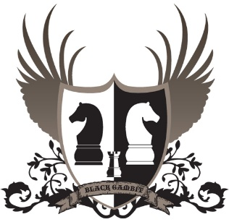
The Knights of Éanna
“Striving for excellence in chess”

The Inaugural John Bolger Cup 2022
Date March 25th – 27th 2022 (Friday – Sunday)
Venue Coláiste Éanna, Hillside Park, Ballyroan, Rathfarnham, D16E248
Prize Fund Over-all Guaranteed Minimum Prize Fund €4500 (Master’s section only) guaranteed prize fund €2250
Rate of Play Maters: 90 minutes + 30 second increment, Championship/Major/Challenger: 75 minutes + 30 second increment.
Sections Masters: 1900+ (5 rounds FIDE rated) Championship: 1550 – 1950 (6 rounds ICU rated) Major: 1150 – 1599 (6 rounds ICU rated) Challenger: Below 1200 (6 rounds ICU rated)
Timetable
Late registration: Friday evening 6:30-7:15pm surcharge €10 above entry fee
Maters: Championship/Major/Challenger: Round 1: Friday 7:30pm Round 1: Friday 7:30pm Round 2 Saturday 11:00am Round 2 Saturday 9:30am Round 3 Saturday 4:00pm Round 3 Saturday 2:30pm Round 4 Sunday 10:00am Round 4 Saturday 7:00pm Round 5 Sunday 3:00pm Round 5 Sunday 10:00am Round 6 Sunday 3:00pm
Prize giving to follow conclusion of the final round (7pm approx.)
Enter online through the ICU web-site, Queries chess@knightsofeanna.ie
The draw for all 4 sections will be published in advance of round 1. Late entrants will be paired against each other where possible.
Great food available in our local eatery The Ballyboden House
We have reserved an area just for our competitors, a place where you can avail of the very special menu with a discount just for you and your friends.

