LIMERICK OPENTRY FORM
Please fill out in BLOCK CAPITALS

Name:___________________________

Address:_________________________
_________________________________

E-Mail:___________________________

Club:___________________________

Section Entered:___________________

Rating:______ I.C.U Number:_____

I request a travelling bye in round:_____


PLEASE MAIL ENTRIES TO:
JOHN CASSIDY
LOYOLA, CUSACK ROAD,
ENNIS, CO. CLARE

ENTRY FEES:

€35 Seniors €25 Juniors
Make cheques payable to: John Cassidy

        
LIMERICK OPEN
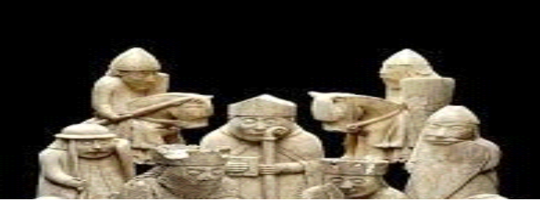

          
DATES – 27th, 28th and 29th October 2018
VENUE – SOUTH COURT HOTEL,
RAHEEN ROUNDABOUT, RAHEEN
LIMERICK, CO. LIMERICK

ENTRY - €35
MORE INFO – JOHN CASSIDY @ 087 2495913

NOTES:
-Irish Players must be ICU members
-Time Control: 1 hour 30 mins + 30 sec increment
-FIDE rules as ICU handbook 2014
-Tournament Controller’s decision is final -- Tournament Controller is Ted Jennings

SCHEDULE FOR TOURNAMENT
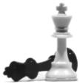ROUND 1 12pm Sat 27th
ROUND 2 5pm Sat 27th
ROUND 3 11am Sun 28th
ROUND 4 4pm Sun 28th
ROUND 5 10am Mon 29th
ROUND 6 3pm Mon 29th

2005 Rory Quinn
2006 GM Nick Pert
2007-2008 GM Alexander Baburin
2009 Ryan Rhys Griffiths
2010-2011 IM Sam Collins
2012 GM Gergely Szabo
2013 FM Colm Daly
2014 GM Petr Neumann

2015 Ioana Gelip
2016 IM Lucian Miron
2017 IM Lucian Miron

PRIZE FUND
 | Philip Hogarty Open | Major (U-1400)
1st | € tbd | € tbd
2nd | € tbd | € tbd
3rd | € tbd | € tbd
Grading Prizes TBD
Prize pool will depend on entries received

RECOMMENDED ACCOMMODATION:

SOUTH COURT HOTEL (venue of tournament)
Address: South Court Hotel, Raheen Roundabout, Raheen, Limerick, Co. Limerick
Phone number: 353 061 487487
Website: info@southcourthotel.com
The 3 star hotel has 124 luxurious bedrooms. All rooms are equipped with free high speed WiFi Internet access, tea/coffee making facility and multi-channel TV.
Room Rates: Reduced rates for participants. Just inform reception that you are playing in the Limk Open chess tournament.
NB: parking is free

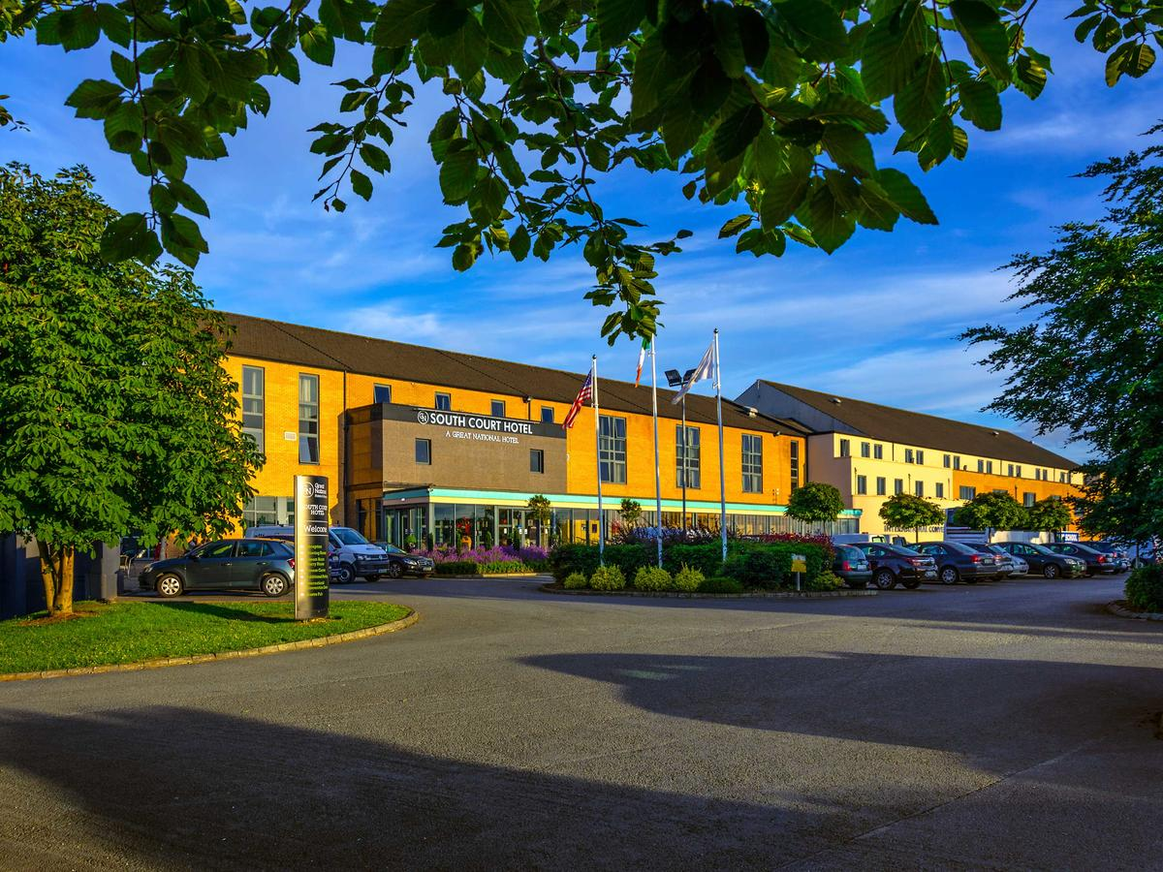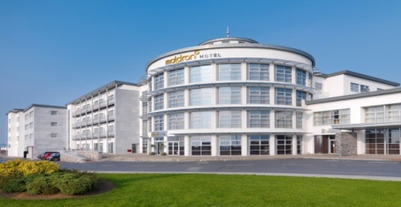
South Court(venue) and Maldron hotel
Other Hotels:
2. Maldron hotel(3.7 km from venue), Roxboro, Limk 061 436100
3. Perys hotel(4.3 km from venue), Glentworth St, Limk city 061 413822
B&Bs: 1. White House, St. Neesans rd, Gouldavoher, Raheen 061 301709
2. Almeda, Ballinacurra rd, Limerick 061 303369

