Munster Junior Chess Championship 2019

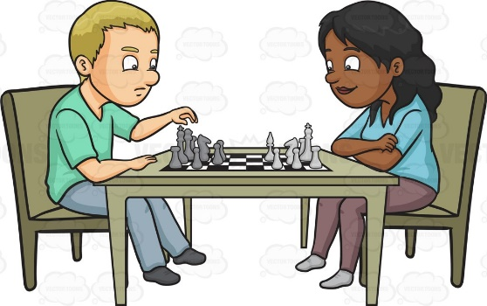

Saturday & Sunday,
Nov. 30 – Dec. 1st 2019.

Venue: West County Hotel, Ennis.

Sections: Under-8, U-10, U-12,
U-14, U-16, U-18.

For all details and to enter, contact:

John Cassidy.. Tel. 087-2495913
Email: ritacassidy16@eircom.net

