Junior Chess Club Coaching – an Introduction
Seminar 10:30 am – 12:00 August 9th, 2019 at the Irish Championships in the Talbot Hotel, Stillorgan.
Facilitators: April Cronin and Brendan Buckley.
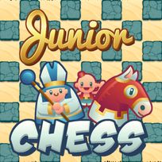

Ever thought about becoming a junior chess coach / school club organiser? Schools and chess clubs are looking for people who can help get chess programmes going for children. It’s an ideal part-time job for a chess-player who likes working with young people.
We will show you how to organise your club competitions, give you ideas on a curriculum to follow, suggest a foolproof way to teach beginners, and advise on behaviour management, child protection, and equipment. We’ll also show you several excellent resources for coaching and organising.
You’ll get a ICU certificate of attendance which you can show to any school or youth club you approach.
See You There!!

