Chess as a Home-Project to Entertain & Educate your kids:

We’ve begun the job of finding a replacement daily routine for ourselves and with families. Despite the real difficulties there is an opportunity for each family to build a new home routine, that hopefully includes and reflects the things we value most. Such as fun, love, learning, art ..
There are many expert people and organisations offering help in the form of free online activities. With games and projects that entertain, educate, and those that teach valuable skills.
Finding the right balance for each family is likely going to involve a period of trial and error for us all.
We’ve lost our old routine. One single activity will not fill the void. Most of us will need a number of new of items in order to fill our daily and weekly diaries.

Moves For Life (MFL) is an organisation of chess experts who support primary schools chess in Ireland. MFL are now offering free online chess activities for children from now until Ireland goes back to normality.
We have created are 3 new project-based activities for children (big and small). Fully supported on http://movesforlife.ie , the projects are for beginners, improvers and advanced players. It will take kids a long time to complete each project. And once they have finished one they can then move up to a new project.

Project 1 - Make your own chess set:
The first project is a mix of arts & crafts plus some chess-like games.
This is a perfect starting point for young kids and those who’ve never played before.
As part of this project we will be holding a craft competition. There are prizes for the best picture received each week. To enter the competition email us at mfl@movesforlife.ie. We’d love to see your pictures.
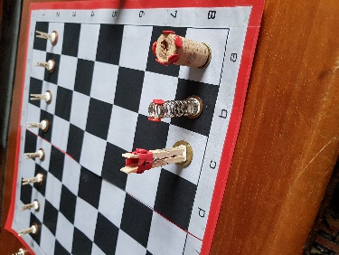
This chess set is made of paper, cork, clothes-pegs and some other stuff. The game on display here is called “SUPER CATS”.
The 14 mini-games for beginners are up on http://movesforlife.ie/our-mission/
Parents and kids can play the mini-games to learn how to play (each mini-game has a 2 minute how to video online).
These enjoyable family games can be played without using computers (less screen time).
Project 2 - Online Chess Competitions:
Fast n’ fun games from 3.00pm to 4.30pm every week, Monday to Friday. Children should know how to play chess for this activity. Games are fast moving, and a mixture of fun and learning. Each week we will introduce instructional videos of famous games. Then players can try to use what they learn from Masters in their own matches.
All welcome, just use the links on the web site to join in these events. Players will learn how to use a timer and think quickly. The timers can really get the adrenaline going.
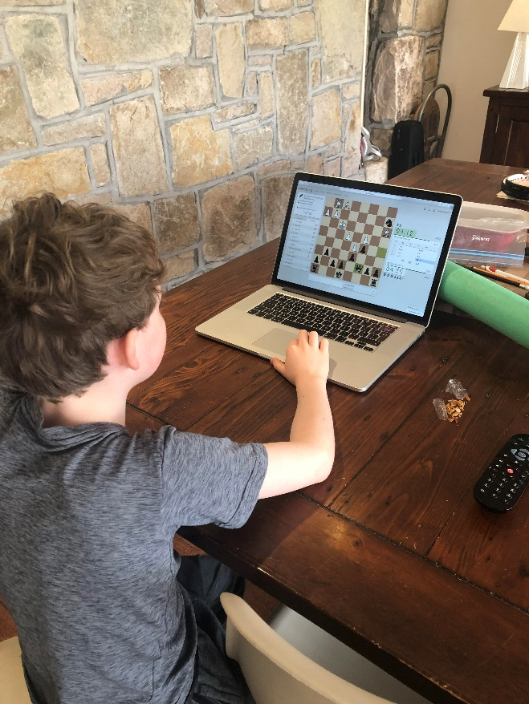

Project 3 – Chess Puzzle Championship:
The third project is a problem-solving competition. At the start puzzles are easy, and are an excellent way to support beginners understanding and development. As players progress to higher level puzzles they will learn new tactical ideas, which will really help children playing in our daily online events. The highest-level puzzles on www.ChessOssity.com require serious concentration and application in order to find the best moves.
Puzzle solving improves many elements of thinking skill. And to both encourage & reward application by players we will be creating new tittles of Irish Champion (Chess Puzzle Solver) to the best performing players at each age group.
There are TROPHIES to be won for the highest points scorers in each age group. The 10 age groups are from U-8’s up to U-16.
The puzzle solvers event will start on Friday 27th of March and finish when life goes back to how it was. Teachers who want to enter your school please email us at mfl@movesforlife.ie and we will send you a code giving all your students free entry to this event.

These MFL projects are free for all interested Irish kids. Visit MFL (http://movesforlife.ie) and try a chess project to see if it’s a good addition to your Child’s Daily Routine.
 | Monday to Friday
9am  10am  1pm  3 pm to 4.30pm  5pm  7pm | Chores – breakfast & cleaning  Education – school assignments  Lunch & fresh air (walk, gardening, shopping).  Chess crafts, puzzle solving & playing new friends online.  Dinner & relaxation time,  Music / Project / Reading / Screen time.

Finally, we would just like to sincerely thank our sponsors and wish everyone well. Keep safe.

