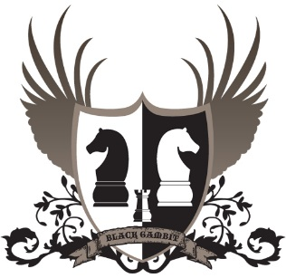
The Knights of Éanna
“Striving for excellence in chess”

The John Bolger International Masters Cup

Date February 17th – 19th 2023 (Friday – Sunday)
Venue Coláiste Éanna, Hillside Park, Ballyroan, Rathfarnham, D16E248
Prize Fund Over-all Guaranteed Minimum Prize Fund €4500 (Master’s section only) guaranteed prize fund €2000
Rate of Play Maters: 90 minutes + 30 second increment, Championship/Major/Challenger: 75 minutes + 30 second increment.
Sections Masters: 1900+ (5 rounds FIDE rated) Championship: 1550 – 1950 (6 rounds ICU rated) Major: 1150 – 1599 (6 rounds ICU rated) Challenger: Below 1200 (6 rounds ICU rated)
Timetable
Late registration: Friday evening 6:30-7:15pm surcharge €10 above entry fee
International Maters: Major/ Éanna Shield/ Challenger: Round 1: Friday 7:30pm Round 1: Friday 7:30pm Round 2 Saturday 11:00am Round 2 Saturday 9:30am Round 3 Saturday 4:00pm Round 3 Saturday 2:30pm Round 4 Sunday 10:00am Round 4 Saturday 7:00pm Round 5 Sunday 3:00pm Round 5 Sunday 10:00am Round 6 Sunday 3:00pm
Prize giving to follow conclusion of the final round (7pm approx.)
Enter online through the ICU web-site, Queries chess@knightsofeanna.ie
The draw for all 4 sections will be published in advance of round 1. Late entrants will be paired against each other where possible.
Great food available in our local eatery The Ballyboden House

